|  |  |  |
| --- | --- | --- |
| **Ex. No. 1** | **Basic Programs** | |
| **Date of Exercise** | | 01-12-2017 |

**Aim:**

To develop Java programs for the following problems:

1. WAP in java to implement the factorial of a given number.
2. WAP to grade the student using java.
3. WAP to perform Tribonacci series of given number
4. WAP to identify the prime numbers between the given range.
5. WAP to achieve the following pattern,

*

* * *

* * * * *

**Algorithm:**

**1.To implement the factorial of a given number.**

1. Start.
2. Read the number from user of which the factorial is to be found and store it in n.
3. Initialize fact=1.
4. Initialize a for loop which starts from i = n till i > 1.
5. Inside the loop calculate sum as fact = fact * i.
6. Display the result.
7. End.

**Source Code:**

package exp1;

import java. util. Scanner;

public class factorial {

public static void main(String [] args) {

Scanner S=new Scanner(System.in);

int n;

System.out.println("Enter a number: ");

n=S.nextInt();

int fact=1;

for(int i = n; i > 1; i--){

Fact = i * fact;

}

System.out.println("The factorial of the number " +n+ " is " + fact);

}}

**Input & Output:**

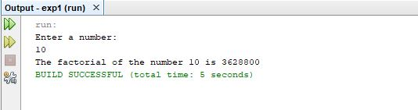

**Algorithm:**

**2.To grade the student using Java.**

1. Start.
2. Read the marks from user of which the grade is to be found and store it in marks.
3. Declare a string variable grade as Null.
4. Using if-else-if ladder calculate the grade according to the marks entered.
5. Display the result.
6. End.

**Source Code:**

package exp1;

import java.util.Scanner;

public class stugrade {

public static void main(String args[]){

Scanner s=new Scanner(System.in);

int marks;

String Grade = null;

System.out.println("Enter the mark of a subject: ");

marks=s.nextInt();

if(marks>=95)

Grade="0";

else if(marks>=90&&marks<95)

Grade="S";

else if(marks>=80&&marks<90)

Grade="A";

else if(marks>=70&&marks<80)

Grade="B";

else if(marks>=60&&marks<70)

Grade="C";

else if(marks>=50&&marks<60)

Grade="D";

else

Grade="Fail";

System.out.println("The grade of the marks obtained is: "+Grade);

}

}

**Input & Output:**

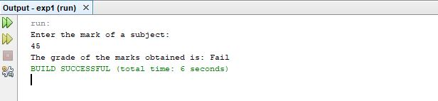

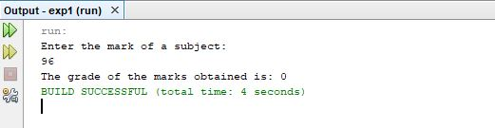

**Algorithm:**

**3.To generate the Tribonacci series of a given number.**

1. Start.
2. Read the number from user till where the Tribonacci series is to be found and store it in num.
3. Initialize three variables a=0, b=0, c=1, d=a + b + c.
4. Initialize a for loop from i=4 till i=num.
5. Inside the loop do the following a=b, b=c, c=d, d=a + b + c.
6. Display the tribonacci series.
7. End.

**Source Code:**

package exp1;

import java.util.Scanner;

public class tribonacci {

public static void main(String args[]){

Scanner s=new Scanner(System.in);

System.out.println("Enter the number till you want to print tribonacci series: ");

int num=s.nextInt();

int a=0,b=0,c=1;

int d=a + b + c;

System.out.println("\n Tribonacci Series: ");

System.out.print(a+ "\t" +b+ "\t" +c);

for(int i=4; i<=num; i++){

System.out.print("\t" +d);

a=b;

b=c;

c=d;

d=a + b + c;

}

System.out.println();

}}

**Input & Output:**

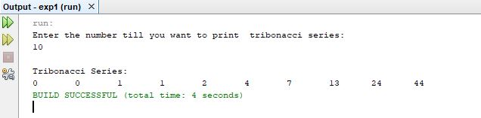

**Algorithm:**

**4.To identify the prime numbers between given range.**

1. Start.
2. Read the starting number from user till where the prime number is to be displayed.
3. Initialize a for loop from i=num till i=num1.
4. Inside the loop, initialize count=0, initialize another for loop from j=2 till j<i.
5. Use if loop inside the for loop to check whether i % j = =0, if it is so increment count, then break.
6. Then check if count==0, if it is so display the number
7. End.

**Source Code:**

package exp1;

import java.util.Scanner;

public class primenos {

static public void main(String args[]){

Scanner s=new Scanner(System.in);

int num,num1,count=0,i,j;

System.out.println("Enter the range between which prime numbers are to be printed: ");

System.out.print("Enter the starting number: ");

num=s.nextInt();

System.out.println("");

System.out.print("Enter the ending number: ");

num1=s.nextInt();

System.out.println("");

System.out.println("The numbers between the range" +num+ " and "+num1+ " is: ");

for(i=num; i<=num1; i++){

count=0;

for(j=2; j<i; j++){

if(i % j==0){

count++;

break;

}}

if(count==0){

System.out.print(i+" ");

}}}}

**Input & Output:**

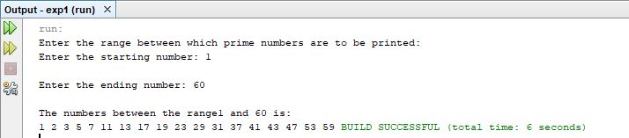

**Algorithm:**

**5.To achieve the given pattern.**

1. Start.
2. Initialize three variables for row, column and number of lines.
3. Initialize a for loop from i=1 till i=3 for number of rows.
4. Inside the loop, initialize another for loop from j=2 till j=i for the number of spaces.
5. Initialize another for loop to display the pattern or stars from k=1 till k = (2 * i - 1).
6. Display the result inside the for loop.
7. End.

**Source Code:**

package exp1;

public class pattern {

public static void main(String args[]){

int i, j, k;

for(i=1; i<=3; i++){

for(j=2; j>=i; j--){

System.out.print(" ");

}

for(k=1; k<=(2*i-1); k++){

System.out.print("*");

}

System.out.println(""); } }}

**Input & Output:**

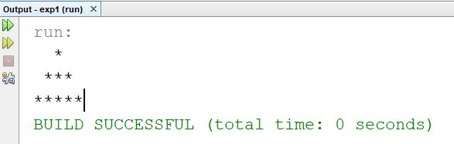

**Video URL:**

**<https://www.youtube.com/watch?v=6bZ2j8az7H8>**

**Result:**

The program to do the given basic programs is implemented successfully and the output is verified.